**VOICE CONTROLLED CAR USING ARDUINO**

ABSTRACT:

The project describes the implementation of a voice controlled robotic car using Arduino. In this project, the user gives specific voice commands to the robot through an Android app installed on the Smartphone. At the receiving side, a Bluetooth transceiver module receives the commands and forwards them to the Arduino on the robotic car. We accept the command character by character from the serial buffer sent by the Android app and combine them to form a string. We have created some pre-defined functions named as Front, Back, Right, Left and Stop to the Arduino, whenever the received command matches with the character in switch case, the Arduino executes the command and makes a call to the function mentioned inside it. And then the robot works according to the controls and speed specified in the function.

COMPONENTS:

• Arduino Uno

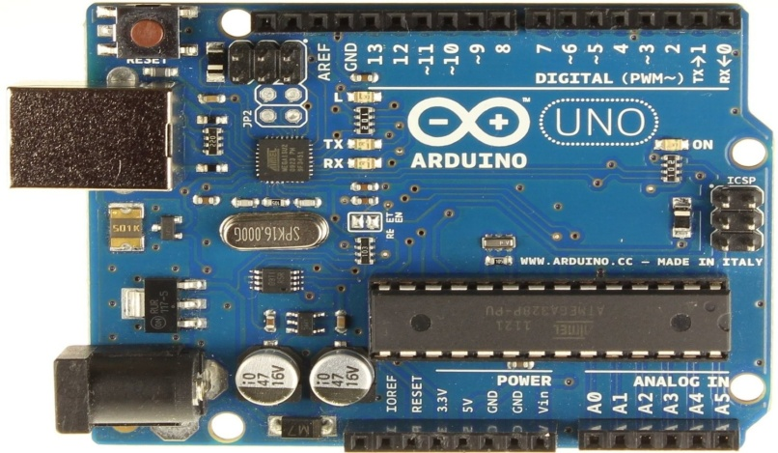

• L293D Motor Driver Shield

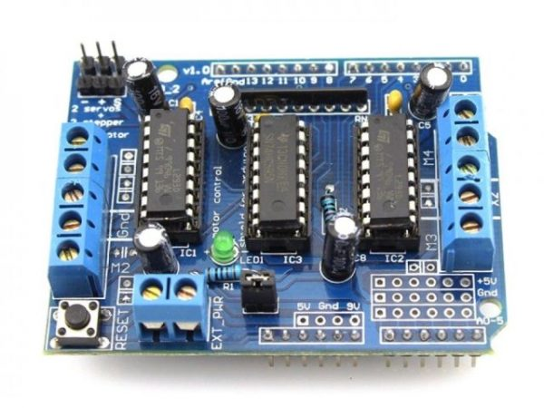

• DC Motors x4

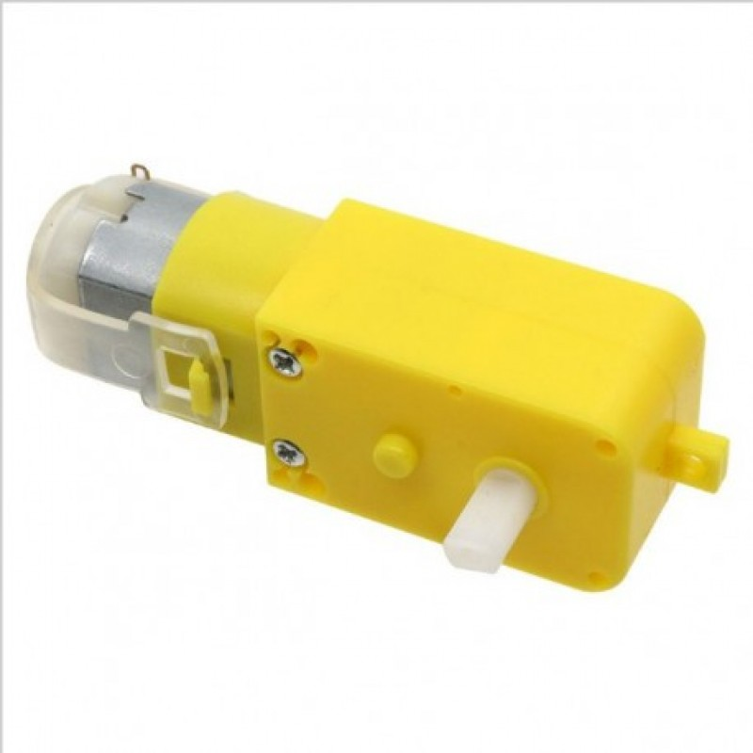

• Wheels x4

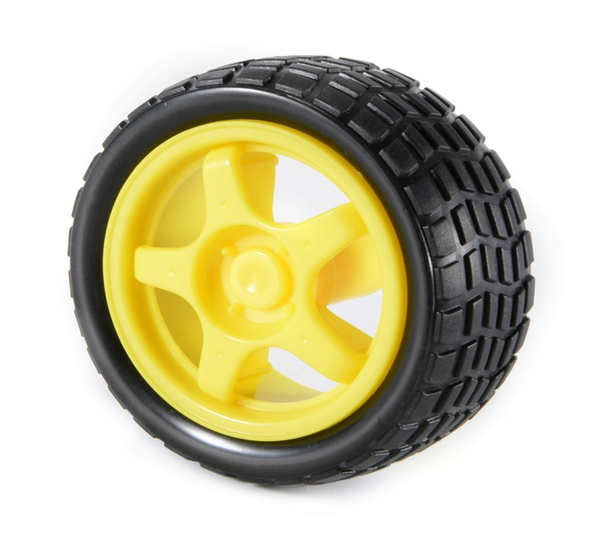

• Robotic Car Chassis

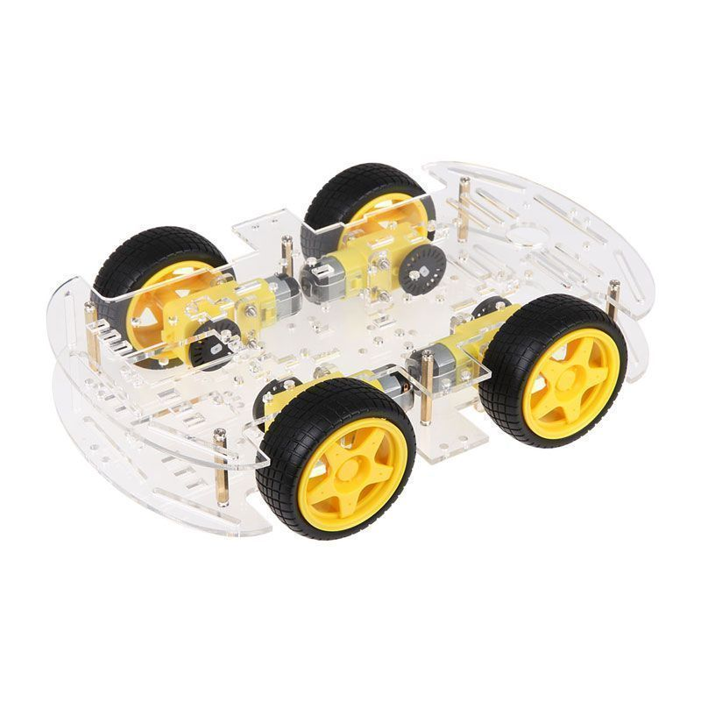

• Connecting Jumper Wires

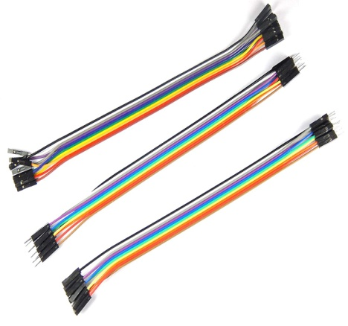

• Bluetooth Module HC-05

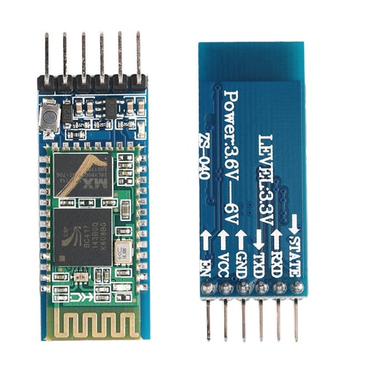

• Power Bank

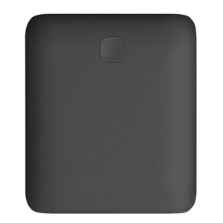

• USB Cable For Arduino Uno



**CIRCUIT DIAGRAM:**

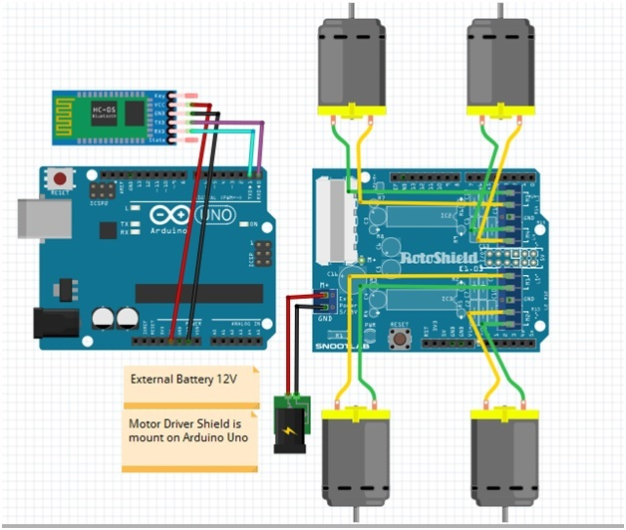

**BLOCK DIAGRAM:**

